Synopsis

Automated Credit Risk Categorization for Loan Approval

Problem Id: 8

Student Name : Mohd Uvais Ahmed
University Roll number : 2028770
Student Name : Mohammad Rayyan Farooqui
University Roll number : 2028768

Section : G

- Problem Description:

In banks, giving a loan is a risky decision. The bank has to decide whether a person will return the money or not. If the person fails to repay, it is called a default. Checking every applicant manually can be slow and sometimes inaccurate.
In this project, we try to solve this problem using machine learning. We create a simple system that predicts whether a loan applicant is safe or risky. The decision is based on three factors: Credit Score, Annual Income, and Debt-to-Income Ratio.
We generate a dataset of applicants and assign them as safe or risky based on basic logic. Then we train a model using Logistic Regression so that it can learn patterns and make predictions for new applicants.

We also check the performance of the model using metrics like Precision and F1 Score.

- Steps of Implementation:
.
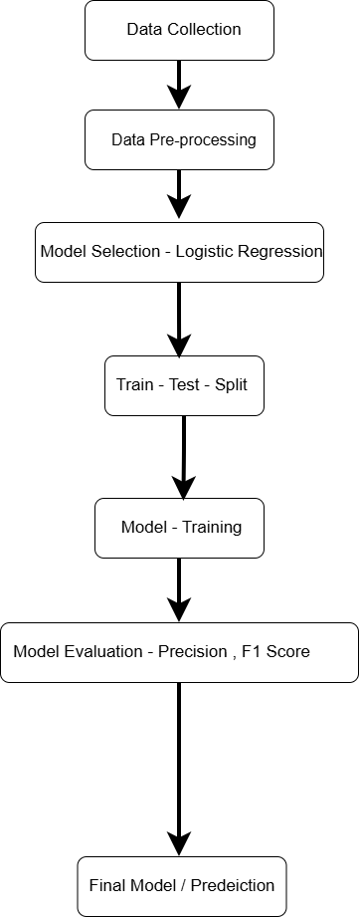
Fig. 1 Sample architecture

- Expected Modules/ Libraries to be used :
• NumPy – for generating random data
• Pandas – for creating and handling dataset
• Matplotlib / Seaborn – for basic graphs
• Scikit-learn – for model training and evaluation

- Expected Evaluation metrics and Plots to be used:
Metrics:
- Precision – tells how many predicted risky cases are correct
- Recall – tells how many actual risky cases were found
- F1 Score – balance between precision and recall
Plots:
- Bar graph to show safe vs risky applicants
- Histogram for feature distribution
- Confusion matrix to check predictions

- Required topics from the subject:
Python Basics – To write code
Basic Data Handling – Using Numpy & Pandas library.
Data visualisation – Using Matplotlib & seaborn .
Machine learning – Understanding supervised learning, classification, and how models learn . from data.
Logistic Regression – Used to predict whether an applicant is safe or risky based on input . . features.
Evaluation Metrics – Concepts like Precision , Recall and F1 Score used to measure Model . . performance

- Platform Required:
- Jupyter Notebook
- Python (VS Code / Anaconda / IDLE)

- Books and Link Sources:

- Python Programming using Problem Solving Approach — Reema Thareja
- Fundamentals of Data Science — Gaurav Vaish
- GeeksforGeeks - https://www.geeksforgeeks.org
- Introduction to Machine Learning — Ethem Alpaydin

